Biological limits to longevity do not explain the recent slowdown in UK life expectancy

Devine RE1, McCartney G1, Minton J1

1.NHS Health Scotland, Meridian Court, 5 Cadogan Street, Glasgow. G2 6QQ.

WORD COUNT (paper): 2363 (max allowed 2500)

WORD COUNT (abstract): 272 (needs cut down to 250)

***What is already known on this subject:***

Since 2012-14, the previously steady rate of improvement in life expectancy in the UK has begun to slow down.  The underlying changes in mortality trends has affected men and women, and are exacerbating health inequalities.  Some commentators have responded that this slowdown in life expectancy improvement may be due to the human species reaching a natural biological limit to longevity.

***What this study adds:***

This study brings together theory and data to provide evidence that the recent stall in improvement in life expectancy in the UK is not due to a biological limit. We show an average of substantial and consistent improvement in life expectancy across a group of high income countries and that the UK is dropping to a position of below average life expectancy among a group of comparator countries. This, in the context of other recently published work, requires we find alternative explanations for the life expectancy stall in the UK, other than biological limit.

Abstract

Background

In the UK there has been a notable slowdown in rates of improvement in life expectancy in recent years. One intuitive interpretation of these facts is that there is a maximum biological limit to longevity, and as we approach this limit, rates of improvement will slow. This paper introduces and updates some key demographic findings to investigate whether the recent slowdown is explained by such phenomena.

Methods

Analyses presented in a demographic paper, White (2002), were replicated and updated with new data available from the Human Mortality Database (HMD). For the 21 high income countries chosen by White, we have graphed life expectancy over time; calculated the correlation coefficient (r2) to examine the linearity of trends; graphed life expectancy against annual change in life expectancy to examine whether improvements are advancing or not; and graphed the change in life expectancy for 21 countries over 6 decades to examine the evolution of the gradient of life expectancy improvement.

Results

Life expectancy at birth for the 21 countries analysed showed a linear improvement up to 2016. Our update of the analysis by White suggests substantial improvements in life expectancy (around 0.15 – 0.2 years/year) across a number of countries, rather than much smaller improvement expected if a biological limit to longevity was being approached. Additionally, the UK has shifted from being among the countries with the highest life expectancies, to having a slightly below average life expectancy.

Conclusion

The recent slowdown in life expectancy gains observed in the UK cannot be explained by a general tendency for life expectancy improvement rates to slow down as life expectancy increases. Other explanations are required as to why improvements have slowed since 2012.

Introduction

It could be argued that the substantial reduction in human mortality, and the resulting increase in life expectancy, has been the greatest achievement of the last 150 years.[1] Period life expectancy at birth has generally increased since the 1950s across high income countries.[2,3] Improvements in life expectancy have variously been attributed to improvements in nutrition, sanitation, housing, education, institutions, the welfare state, disposable incomes as well as healthcare, in particular vaccines and antibiotics.[4–7] Since the end of the Second World War, improvements in survival have continued, largely propelled by decreases in mortality during adulthood. Until very recently, only severe epidemiological or socio-political shocks, such as the 1918 influenza pandemic, the world wars and the rapidly changing politics and economics in the Soviet Union, have interrupted the steady rise in life expectancy across high income countries.[8] Economic recessions alone have generally not had an impact on overall life expectancy because of the mixed impacts across different causes of death.[9]

However, life expectancy in the UK, and across many high income countries, has been stalling since 2012 and, in some populations, has started to decline.[10–13] Given that many high income countries have seen improving life expectancy for many decades, it has been suggested that the easiest gains in population improvements have already been made and that a slowdown in life expectancy is to be expected as a result of approaching a biological limit to longevity.[14]

If there is a biological maximum limit to longevity, it can be anticipated that, as populations age, more of the population will reach this upper longevity limit and so trends towards ever increasing life expectancies would tail off. Additionally, there would be a notable slowdown in the rate of annual improvement in life expectancy, seen first in those countries with the highest life expectancies. Some commentators believe that, since the UK already has a high life expectancy, further improvements at the high rates previously experienced cannot be expected. If this is correct, it would be expected that: (i) globally, the countries with the highest life expectancies would see the most reduced improvement in life expectancy; (ii) the rate of life expectancy improvement would advance less quickly over time; (iii) in the UK, those (least deprived) sectors of the population with the highest life expectancy would see the most reduced improvement; and (iv) stalled overall improvements would be due to static mortality rates for older age strata rather than because of increasing mortality rates at younger ages.

This paper explores whether any long-term tendency for rates of life expectancy improvement to slow down could explain the recent trends in the UK.

Methods

We followed the methods used to produce Figure 1 of White 2002.[15] White’s paper showed period life expectancy for the unweighted average of 21 high income countries (Australia, Austria, Belgium, Canada, Denmark, Finland, France, West Germany, Greece, Ireland, Italy , Japan, Netherlands, New Zealand, Norway, Portugal, Spain, Sweden, Switzerland, United Kingdom, United States) and we have re-analysed and updated to include data up to 2016. We conducted supplementary analyses by repeating our analyses including all 40 countries included in the Human Mortality Database for which data were available (see supplemental data).

We further extend White’s research and conclusions about life expectancy in a number of ways: first, we replicate and update White’s Figure 3 from the period 1955-1996 to 1955-2016, with data form the HMD. Second, for the 21 countries chosen by White, we have graphed life expectancy over time and calculated the correlation coefficient (r2) to examine the linearity of those trends. Third, we produce a version of this same graph considering each decadal period from 1955-2016 separately, to investigate both the evolution of this relationship and whether it has become more or less supportive of biological limits as a key explanation. Within each of these decadal periods we also highlight the UK, to show how its life expectancy compares against the other high income nations.

Data and Code

All analyses make use of data from the Human Mortality Database (HMD), using data, where available, for those 21 high income countries included in White’s paper. Analyses were performed using the R programming language [16] and all code required to replicate the analyses is publically available on a GitHub repository.[1] Data availability for all the countries in HMD is illustrated in the supplemental data.

Results

The trend of improvement in life expectancy for high income countries since 1996

White’s paper analysed data from 1955 to 1996. Period life expectancy at birth for the 21 countries analysed showed a linear improvement from 1955 to 2016 (Figure 1a). Life expectancy seems to have been improving faster between 1955 and 2016 (mean of 0.216 years/year), than between 1955 and 1996 (mean of 0.211 years/year; data not shown). This indicates that the stalling across many countries has not been sufficient to drop the mean increase (when data up to 2016 are included).

Life expectancy at birth in the UK fell below the average of these 21 high income countries in the 1960s, started to converge in the 2000s and then fell back after 2012 (Figure 1b).

The correlation of mean period life expectancy over time demonstrated a near perfect R-squared value (> 0.99) for data between 1955 and 2016 (see Table 1). The ‘lowest’ and ‘highest’ categories refer to the country with the lowest and highest life expectancy at birth in 1955. R squared values of this magnitude indicate the high degree of linearity in the improvement in life expectancy in these countries over time. The t statistics are all very large, and correspond to p values much smaller than 0.01. These analyses were repeated with all countries listed in the Human Mortality Database (see supplemental data).

.

Table 1: R squared values of life expectancy at birth in 1955 for 21 countries against average annual gain in life expectancy per year between 1955 and 2016. For key to country codes see supplemental data.

|  |  |  |  |  |  |  |
| --- | --- | --- | --- | --- | --- | --- |
| **Population** | **Life expectancy at birth in 1955** | **Mean annual gain per year between 1955 and 2016** | **Standard Error** | **t value** | **R squared** | **Adj. R Squared** |
| Lowest life expectancy countries in 1950 | 61.400 | 0.299 | 0.007 | 41.250 | 0.966 | 0.965 |
| Highest life expectancy countries in 1950 | 73.430 | 0.198 | 0.004 | 52.871 | 0.979 | 0.979 |
| Mean for all countries | 69.094 | 0.216 | 0.001 | 152.118 | 0.997 | 0.997 |

Figure 1(a): Mean life expectancy of high income countries from 1955 – 2016; r2 = 0.99

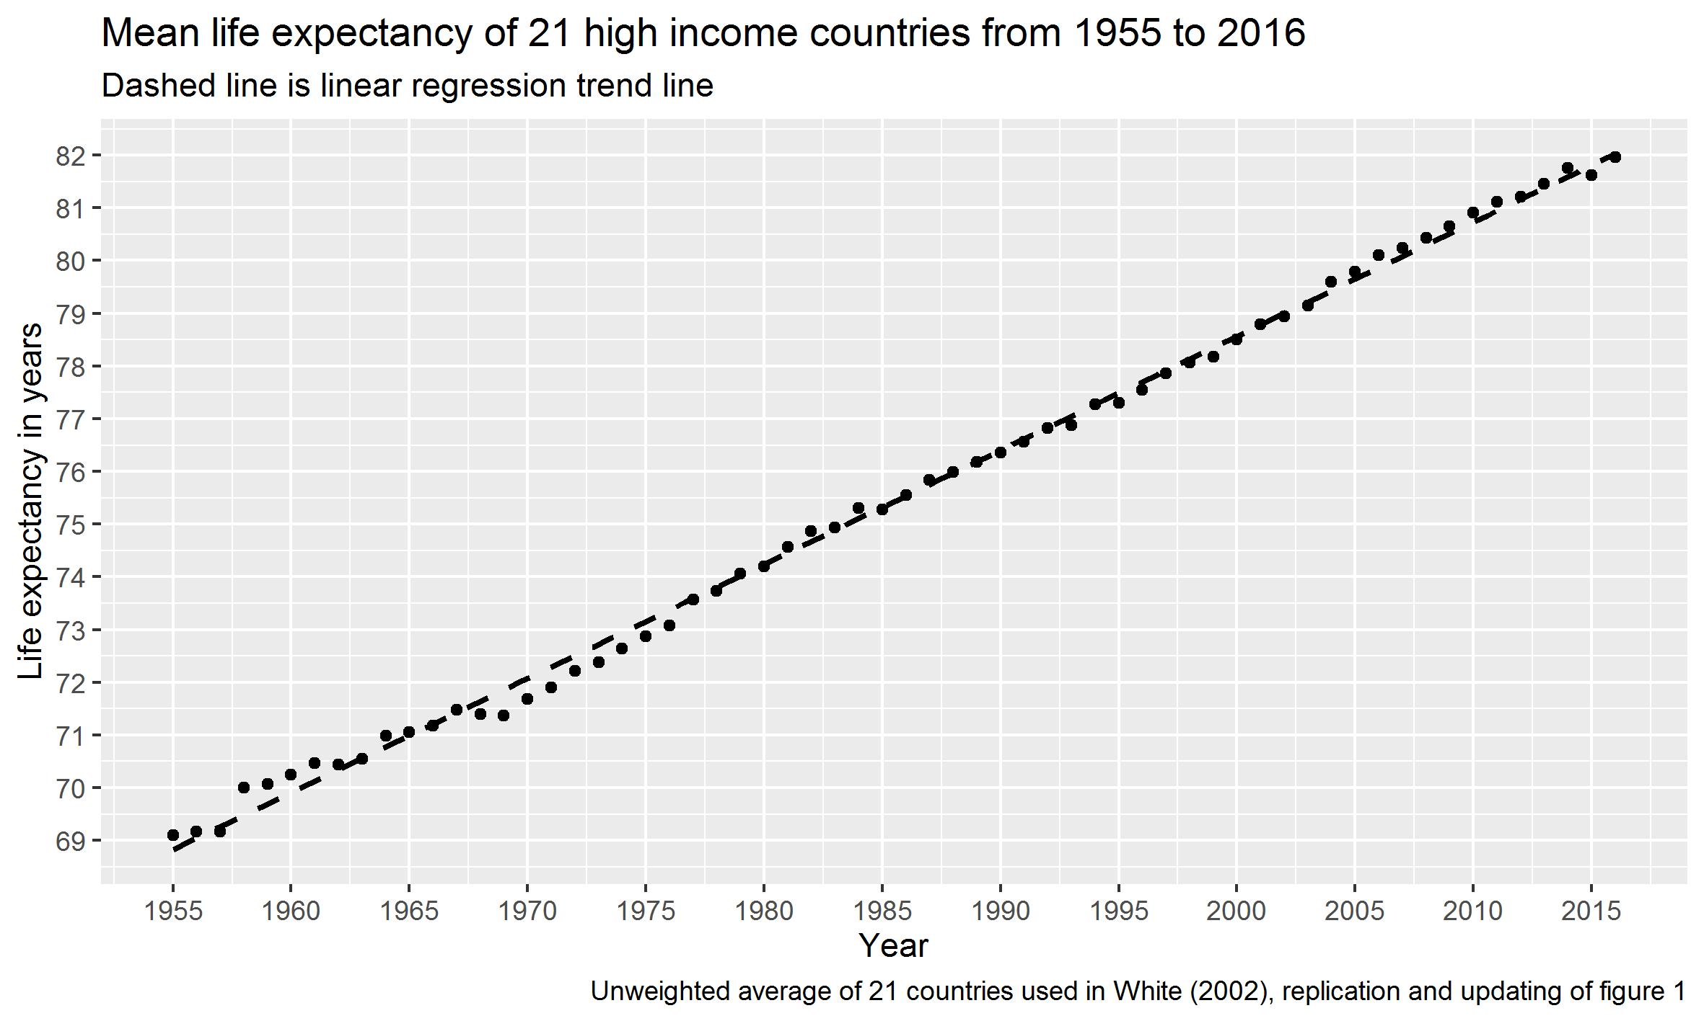

Figure 1(b): Life expectancy over time for average of high income countries and the UK, showing the UK’s relative position and stalling life expectancy after ~2012 (1955-2016).

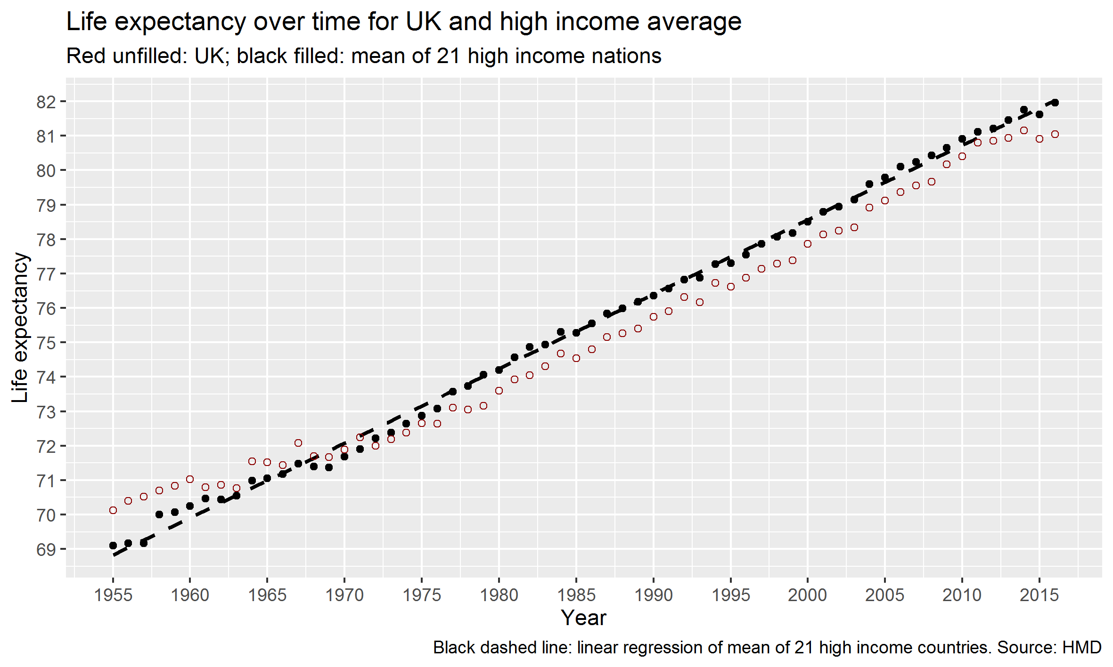

The rate of improvement in life expectancy

If a biological limit were being approached, life expectancy improvement would advance less quickly over time. When we look at mean annual change in life expectancy, the data show a lower limit of around 0.15 – 0.20 years/year improvement. Over the studied period of time, the rate of advance in life expectancy has settled at this rate of improvement rather than slowed towards zero.

Figure 2 shows data for the life expectancy at birth in 1997 for 21 high income countries, against average annual change in life expectancy in years per year, between 1955 and 2016. In 1997 USA had one of the lowest life expectancies at birth and Japan had the highest by a substantial margin. The improvement each year is across a narrower range for these countries.

By splitting the data in to decadal periods (Figure 3) we can see more clearly the evolution of the gradient over time. We note that, based on the gradient, all countries except USA could expect improvement of above 1.5 years per decade. This suggests that while the rate of life expectancy improvement is slower with increasing life expectancy, there is still a substantial improvement. Rather than evidence of improvement stopping as an absolute ceiling of longevity is reached for countries with the highest life expectancy, we see continued improvement.

Considering the relationship between contemporary life expectancy and the rate of change in life expectancy in Figure 3, the inverse relationship has become both less certain and less of a gradient over time, the opposite of what would be expected if a ‘natural’ ceiling was being reached. Furthermore, the rate of improvement over time across countries converges at around 0.15 to 0.20 years of life expectancy improvement per year from a much wider spread of rates in the earlier period.

For each of the decades, the position of the highlighted point in the horizontal distribution shows the relative ranking of life expectancy for the UK compared with the other high income countries in this group. We can see the UK has shifted from one of the higher life expectancy countries, to having a slightly below-average life expectancy over time. This again runs counter to the idea that a general tendency towards life expectancy slowdown explains the recent data, as then we would expect countries like Japan and Norway to have experienced the largest slowdowns in recent years. This was not illustrated when the larger group of HMD countries was analysed (see supplemental data).

Figure 2: life expectancy at birth in 1997 for 21 high income countries, against average annual change in life expectancy in years per year, between 1955 and 2016. See table 2 for country codes.

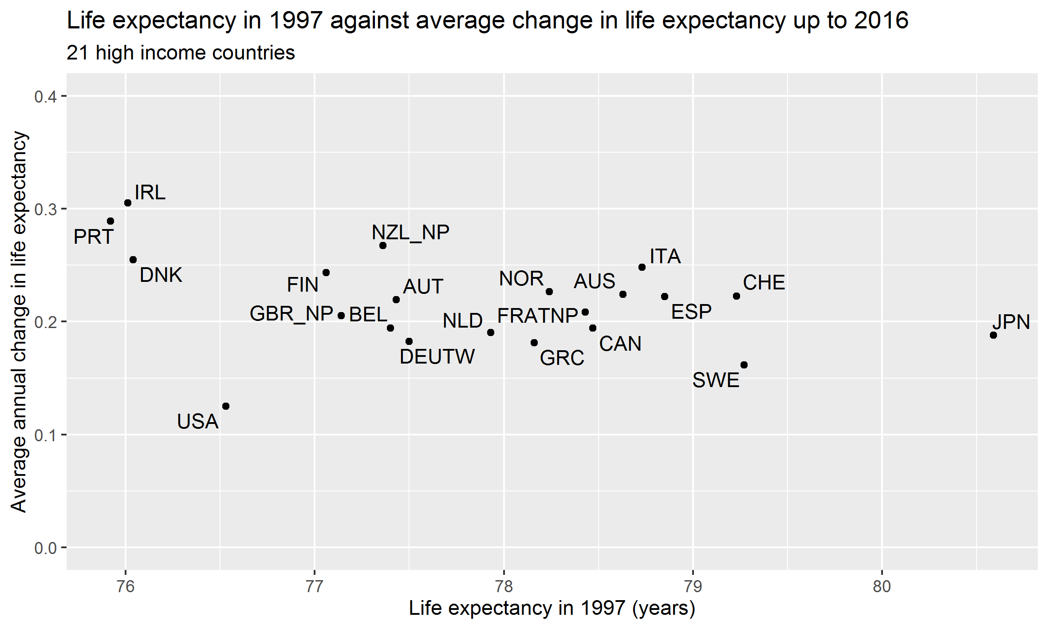

Figure 3: life expectancy at birth at start of decade for 21 high income countries, against average annual change in life expectancy (in years per year) over 6 decades

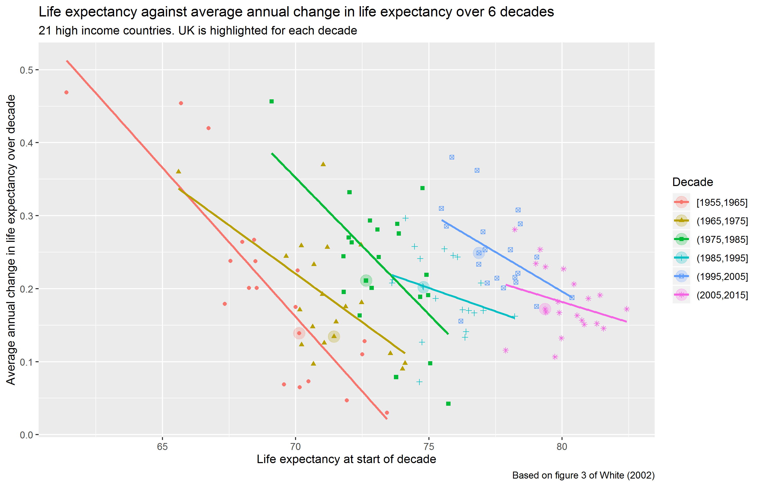

Discussion

Overall, these analyses have demonstrated that (i) the linear improvement in life expectancy in the group of high income countries studied by White has continued 20 years longer than shown in White’s analysis; (ii) there are continued rapid improvements in countries with the highest life expectancy; (iii) while the long-term inverse relationship between life expectancy and rate of improvement in life expectancy has become weaker over time, it does seem to be settling at around 0.15- 0.20 years/ year (7.8 to 10.4 weeks/ year) improvement. If the slowdown in life expectancy improvement in the UK is due to a biological limit we would expect the UK to be less affected by this biological limit since we are further down the life expectancy ‘league table’ overall. In fact, what we see is the UK worse affected than countries like Japan which have higher life expectancy.

Strengths

We provide an intuitive graphical means of investigating whether the stalling of life expectancy across countries is likely to be due to populations reaching a natural limit to human longevity.

In White’s analysis, 21 high income countries were chosen because they were industrially developed, internally at peace, had a population in the millions throughout the period, and had complete data back to 1961. Each country also had access to similar technologies at the same time. These countries were considered to be a comparable group with respect to life expectancy. We chose to perform updated analyses on the same group of countries as chosen by White, to allow comparison within order to examine whether the findings are replicable when more recent data is included.

**Limitations**

The results using all HMD countries are not similar to the results of the 21 high income countries, but in ways that are understandable and support White’s choice of the 21 countries in 2002. The main difference is a discontinuous rate of improvement for the average, with a faster rate of improvement between the mid-1990s and mid-2000s, and a much less linear and shallower improvement for the worst performing countries (see supplemental data). There are issues with data availability when including all HMD countries, which results in like not being compared with like; when repeating our analysis of life expectancy since 1955, it is not possible to include all HMD countries since good quality data for some of these countries were not added to the database until the mid-1980s (see supplemental data). The inclusion of the Eastern European countries introduces the reversal of life expectancy that occurred in the 1990s associated with the rapid transition to a market economy.

Further analysis could include weighted rather than unweighted average life expectancies. We have only looked at high income countries; this is not a comprehensive international analysis.

How this work relates to other published work

In addition to these analyses, comparison with previous published work contributes to our investigation of whether a limits-to-longevity hypothesis could explain the recent stalling in life expectancy in the UK.

There are other logical reasons as to why the recent trends in the UK cannot be due to natural biological limit. If a maximum human longevity did exist, and is being reached in the UK, those (least deprived) sectors of the population with the highest life expectancy would see the greatest reductions in the rate of improvement, while the most deprived would continue to make faster gains. Recent published work has shown this clearly is not the case in England or Scotland.[17,18] Fenton et al’s analysis of percentage change in age-standardised mortality rate by deprivation quintile in Scotland showed that age-standardised mortality rate worsened between 2012 and 2017 in the most deprived fifth of the population, compared with the least deprived.[19] Rather than reaching a biological maximum limit to longevity, it is possible that life expectancy data in the UK is being driven by increasing inequality in mortality rates; by those most deprived population groups who are suffering the lowest life expectancy.

In addition, if a maximum limit to longevity was being reached, stalling of life expectancy would be noted in the oldest age groups first. This is contrary to a recently published decomposition analysis of mortality trends in Scotland.[20] The authors reported a wide range of causes of death were responsible for the observed changes in life expectancy growth in Scotland since 2012, and almost all age-groups saw worsening mortality trends. Life expectancy trends are being impacted by increases in mortality in the middle-aged population; if a maximum longevity was being reached we would expect to see a decrease in improvement in older age groups, not an increase in mortality in midlife. The main findings from this decomposition analysis were that an increase in drug-related deaths in 35-54 year olds, and a decrease in improvement in cardiovascular mortality mostly in 55-74 year olds, were driving a stall in life expectancy improvement.[20]

Conclusions

The UK’s recent slowdown in life expectancy is unlikely to be explained by reaching a maximum upper limit in life expectancy. Life expectancies in countries with the highest life expectancies are continuing to grow at a rate of more than one year of age per decade, rather than slowing down towards zero increase. The relationship between life expectancy at the start of a period, and average annual increases over that period, has become weaker rather than stronger over time. The UK’s relative life expectancy position has declined rather than improved since 1955. The trends observed in the USA, in particular, and the UK to a lesser extent, are distinct from any general pattern of slowdown in life expectancy in high income countries, and signal that these countries have been diverging from more general trajectories. We conclude that the limits-to-longevity hypothesis is unlikely to explain the recent stall in life expectancy. Other explanations are required as to why rate improvements have slowed since 2012, including those considering the influence of fiscal policies and economic change.

References

1. Rosling H, Rosling O, Rönnlund A (2018) Factfulness: Ten Reasons We’re Wrong About the World--and Why Things Are Better Than You Think. Factfulness: Ten Reasons We’re Wrong About the World--and Why Things Are Better Than You Think.

2. Christensen K, Doblhammer G, Rau R, Vaupel JW (2009) Ageing populations: the challenges ahead. The Lancet 374: 1196–1208. doi:10.1016/S0140-6736(09)61460-4.

3. Wilmoth JR (1998) The future of human longevity: a demographer’s perspective. Science 280: 395–397. doi:10.1126/science.280.5362.395.

4. Hanlon P, Carlisle S, Hannah M, Reilly D, Lyon A (2011) Making the case for a “fifth wave” in public health. Public Health 125: 30–36. doi:10.1016/j.puhe.2010.09.004.

5. Floud R, Fogel RW, Harris B, Hong SC (2014) Health, Mortality and the Standard of Living in Europe and North America since 1700. Floud R, Fogel RW, Harris B, Hong SC, editors Edward Elgar Publishing. doi:10.4337/9781784713072.

6. Szreter S (1988) The Importance of Social Intervention in Britain’s Mortality Decline*c* .1850–1914: a Re-interpretation of the Role of Public Health. Soc Hist Med 1: 1–38. doi:10.1093/shm/1.1.1.

7. Fogel RW (2004) The Escape from Hunger and Premature Death, 1700–2100: Europe, America, and the Third World. Cambridge: Cambridge University Press. doi:10.1017/CBO9780511817649.

8. Zajacova A, Montez JK (2017) Macro-level perspective to reverse recent mortality increases. The Lancet 389: 991–992. doi:10.1016/S0140-6736(17)30186-1.

9. McCartney G, Hearty W, Arnot J, Popham F, Cumbers A, et al. (2019) Impact of political economy on population health: A systematic review of reviews. Am J Public Health 109: e1–e12. doi:10.2105/AJPH.2019.305001.

10. Case A, Deaton A (2015) Rising morbidity and mortality in midlife among white non-Hispanic Americans in the 21st century. Proc Natl Acad Sci U S A 112: 15078–15083. doi:10.1073/pnas.1518393112.

11. Hiam L, Dorling D, Harrison D, McKee M (2017) Why has mortality in England and Wales been increasing? An iterative demographic analysis. J R Soc Med 110: 153–162. doi:10.1177/0141076817693599.

12. Fenton L, Minton J, Ramsay J, Kaye-Bardgett M, Fischbacher C, et al. (2019) Recent adverse mortality trends in Scotland: comparison with other high-income countries. BioRxiv. doi:10.1101/542449.

13. Changing trends in mortality: a cross-UK comparison, 1981 to 2016 - Office for National Statistics (n.d.). Available: https://www.ons.gov.uk/releases/changingtrendsinmortalityacrossukcomparison1981to2016. Accessed 22 July 2019.

14. Parry L, Steel N, Ford J (2018) Slowing of life expectancy in the UK: Global Burden of Disease Study 2016. The Lancet 392: S70. doi:10.1016/S0140-6736(18)32906-4.

15. White KM (2002) Longevity Advances in High-Income Countries, 1955-96. Popul Dev Rev 28: 59–76. doi:10.1111/j.1728-4457.2002.00059.x.

16. R Core Team (2017). R: A language and environment... - Google Scholar (n.d.).

17. Fenton L, Wyper GM, McCartney G, Minton J (2019) Socioeconomic inequality in recent adverse all-cause mortality trends in Scotland. J Epidemiol Community Health 73: 971–974. doi:10.1136/jech-2019-212300.

18. Chapter 5: inequalities in health - GOV.UK (n.d.). Available: https://www.gov.uk/government/publications/health-profile-for-england-2018/chapter-5-inequalities-in-health. Accessed 28 January 2020.

19. Fenton L, Wyper GM, McCartney G, Minton J (2019) Socioeconomic inequality in recent adverse mortality trends in Scotland. BioRxiv. doi:10.1101/542472.

20. Ramsay J, Minton J, Fischbacher C, Fenton L, Kaye-Bardgett M, et al. (2019) How have changes in death by cause and age group contributed to the recent stalling of life expectancy gains in Scotland? Comparative decomposition analysis of mortality data, 2000-02 to 2015-17. doi:10.31235/osf.io/q8rme.

1. <https://github.com/JonMinton/life_expectancy_limits>